|  |  |  |  |
| --- | --- | --- | --- |
| **ILP Examples** |  | | |
| **Date:** | 14 March 2011 | **Release:** | Quote |
| **Author:** | James Ballard | | |
| **Owner:** |  | | |

# Purpose

This document outlines some examples of the report types for the new ILP design.

# Default reports

# Targets

Setting SMART targets is a core activity of personal development planning.

|  |  |
| --- | --- |
| Type | Prompt |
| label | Please ensure targets are SMART: Specific, Measurable, Achieveable, Realistic, Time-bound |
| text | Target (What do you want to achieve?) |
| text | Measure (How will you know you have achieved this?) |
| text | Actions (What do you need to do and is there any support you need?) |
| deadline | Deadline |

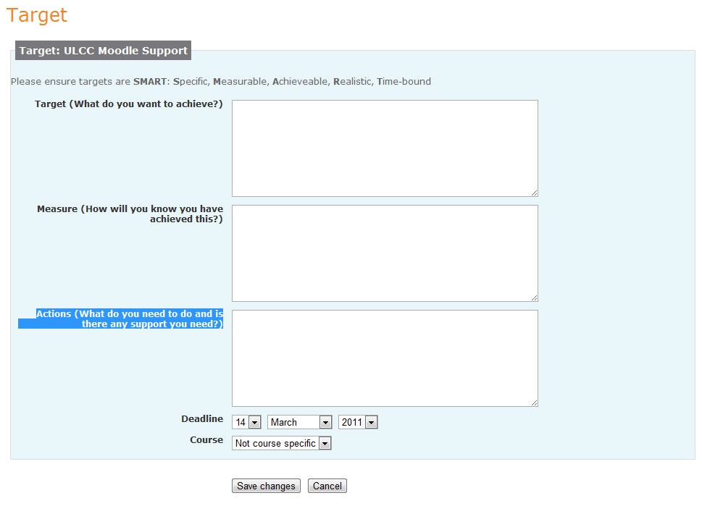Configuration:

|  |  |
| --- | --- |
| Setting | Value |
| usestatus | 0 |
| usecategory | 1 |
| usestate | 1 |
| frequency | 0 |

Roles:

|  |  |
| --- | --- |
| capability |  |
| ilp/entry:view | course_leader, editing teacher, student, tutor, parent |
| ilp/entry:add | course_leader, editing teacher, student, tutor |
| ilp/entry:edit | course_leader, editing teacher, tutor |

# Self-reflection

Reflection on progress is the second main activity.

|  |  |
| --- | --- |
| Type | Prompt |
| label | Reflection upon one's progress is important to enrich the experience and is provided as a reflective journal of your development. Don’t worry about how you write - spelling, punctuation, grammar etc are of no concern whatsoever and this should express experience and thoughts. |
| text | What activities have you undertaken? |
| text | What was the highlight of this? |
| text | What caused you difficulty? |
| text | Did anything surpise you? |

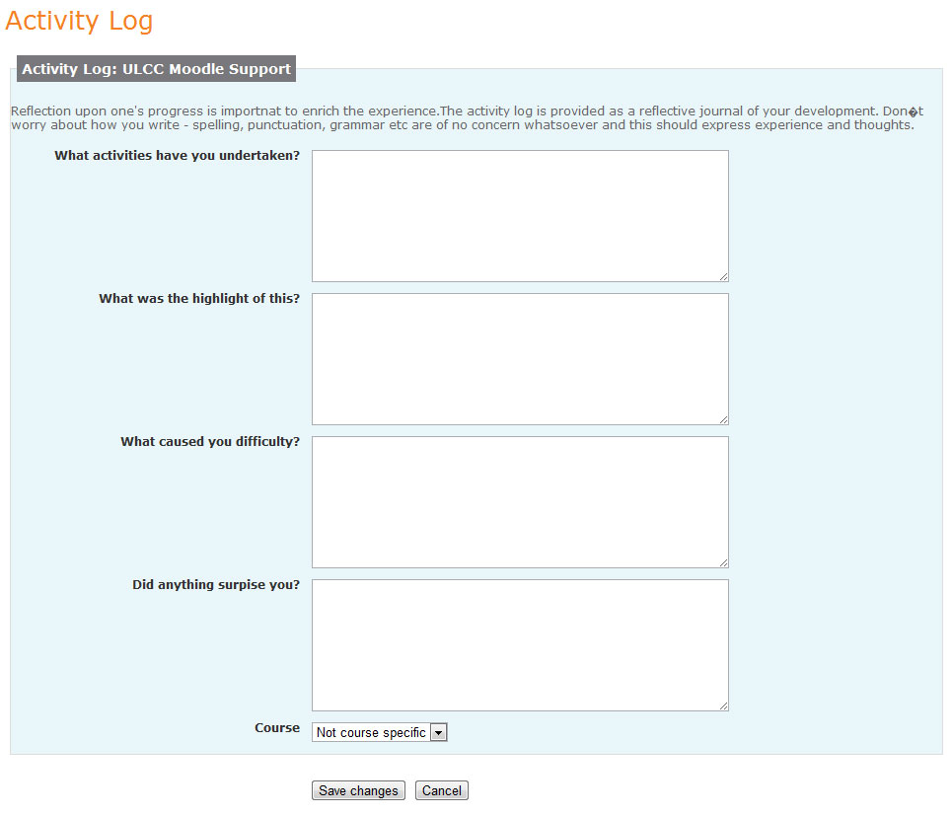

Configuration:

|  |  |
| --- | --- |
| Setting | Value |
| usestatus | 1 |
| usecategory | 1 |
| usestate | 0 |
| frequency | 0 |

Roles:

|  |  |
| --- | --- |
| capability |  |
| ilp/entry:view | course_leader, editing teacher, student, tutor, parent |
| ilp/entry:add | student |
| ilp/entry:edit | student |

# Progress Review

A progress review is completed by the tutor and is often an empty text field.

|  |  |
| --- | --- |
| Type | Prompt |
| text | Tutor progress review |

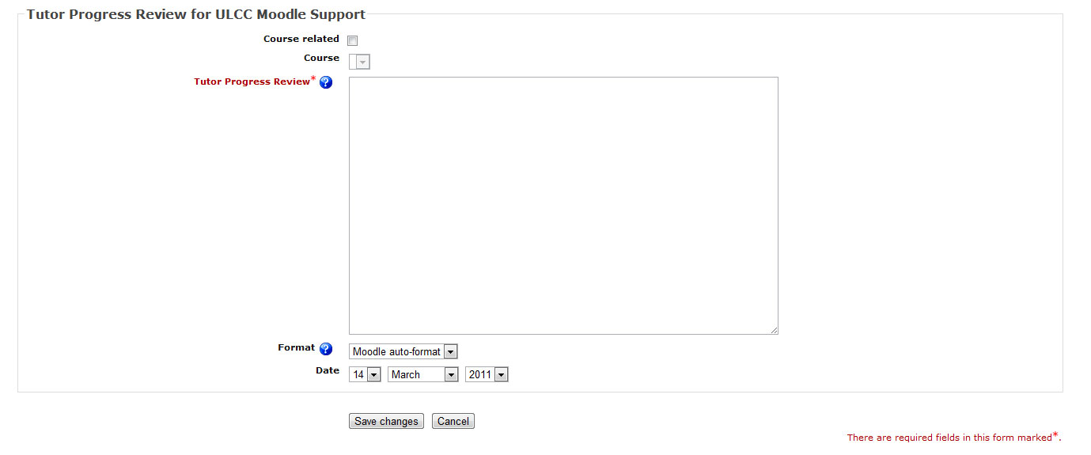

Configuration:

|  |  |
| --- | --- |
| Setting | Value |
| usestatus | 1 |
| usecategory | 1 |
| usestate | 0 |
| frequency | 0 |

Roles:

|  |  |
| --- | --- |
| capability |  |
| ilp/entry:view | course_leader, editing teacher, student, tutor, parent |
| ilp/entry:add | course_leader |
| ilp/entry:edit | course_leader |

# Customised Reports

Each site has its own set of customised reports, some examples of which are included below. These are aimed at covering a spectrum of the different types we might need to support.

# Wellbeing Survey

This allows users to rate aspects of themselves on a 5-point scale and is taken weekly.

|  |  |
| --- | --- |
| Type | Prompt |
| label | The World Health Organisation has helped developed a scale to measure human wellbeing.  The scale has 5 items, and asks about how you have been feeling over the last 2 weeks. Higher numbers mean better wellbeing.  Example: If you have felt cheerful and in good spirits more than half of the time during the last two weeks, put a tick in the box with the number 3 in the upper right corner.  Scoring  5 = All of the time  4 = Most of the time  3 = More than half of the time  2 = Less than half of the time  1 = Some of the time  0 = At no time |
| scale | I have felt cheerful and in good spirits |
| scale | I have felt calm and relaxed |
| scale | I have felt active and vigorous |
| scale | I woke up feeling fresh and relaxed |
| scale | My daily life has been filled with things that interest me |

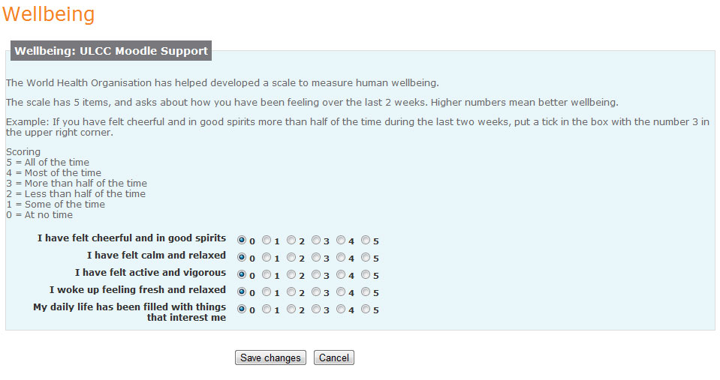

Configuration:

|  |  |
| --- | --- |
| Setting | Value |
| usestatus | 0 |
| usecategory | 0 |
| usestate | 0 |
| frequency | 1 |
| frequnecyformat | weekly |

Roles:

|  |  |
| --- | --- |
| capability |  |
| ilp/entry:view | course_leader, editing teacher, student, tutor, parent |
| ilp/entry:add | student |
| ilp/entry:edit | student |

# Planning for Success

This allows the user to include some general information about themselves and is taken annually.

|  |  |
| --- | --- |
| Type | Prompt |
| text | Goals (What job would you like in the future?) |
| text | Hopes (What do you want to get out of your time at college?) |
| text | Next Steps (What is your next step after this course?) |
| text | Interests (What are your interests?) |
| text | Commitments (Is there anything that may get in the way of your studies/learning? Is there anything that could affect your studies? For example: responsibilities including childcare, difficulties with money, housing, immigration, money...) |
| text | Learning (How do you learn best?) |
| text | Strengths (What things are you good at?) |
| text | Work (Tell us about your work experience.) |
| text | Languages (What languages do you speak? What is your first language?) |
| text | What I find difficult (Is there anything you think you will need help with this year? (for example: English, Maths, Dyslexia, study skills...) |

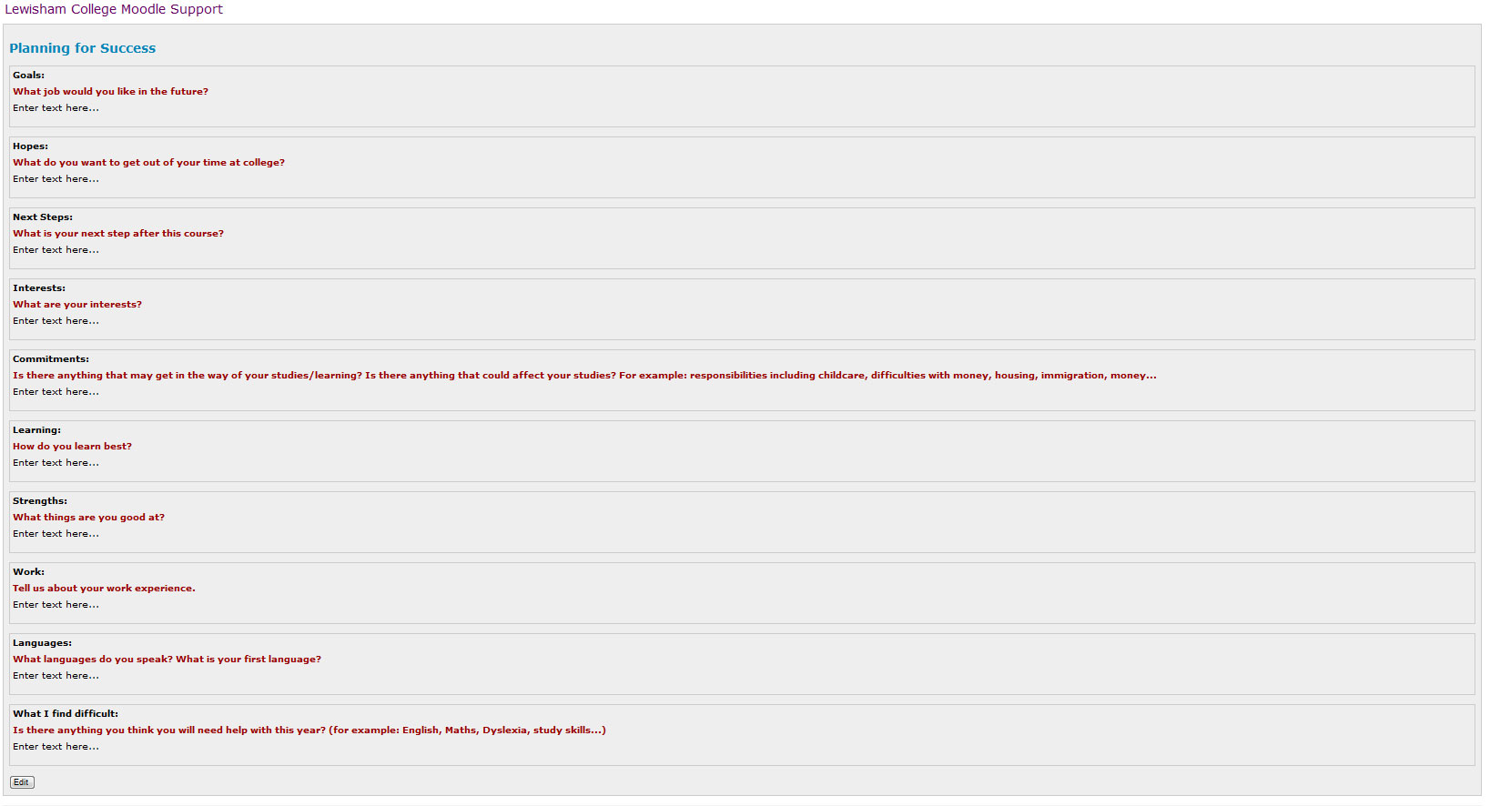Configuration:

|  |  |
| --- | --- |
| Setting | Value |
| usestatus | 0 |
| usecategory | 0 |
| usestate | 0 |
| frequency | 1 |
| frequnecyformat | annually |

Roles:

|  |  |
| --- | --- |
| capability |  |
| ilp/entry:view | course_leader, editing teacher, student, tutor, parent |
| ilp/entry:add | student |
| ilp/entry:edit | student |

# Grid

A number of reports capture miscellaneous style data such as qualifications on entry or results from other systems. These look something like the one below. We need to decide if this is a particular grouped text prompt type that could be handled through the display library. Currently it is a HTML table that can be edited, however this risks that the user can break the HTML structure.

